|  |
| --- |
| LTR COIN AND LOTTERY SERVICES  HELPING TO BUY A GLOBAL LOTTERY |
| LTR Global 100 Linh Dam new urbant city, Hoang Mai , Hanoi, VN  Phone:  Email: |

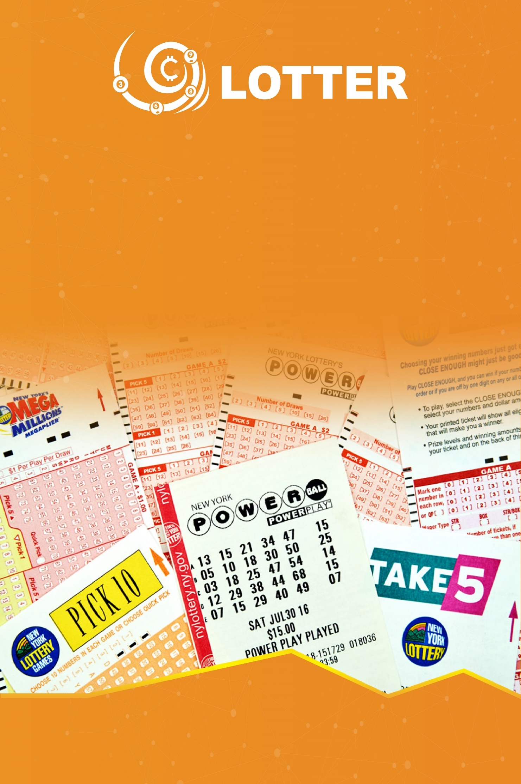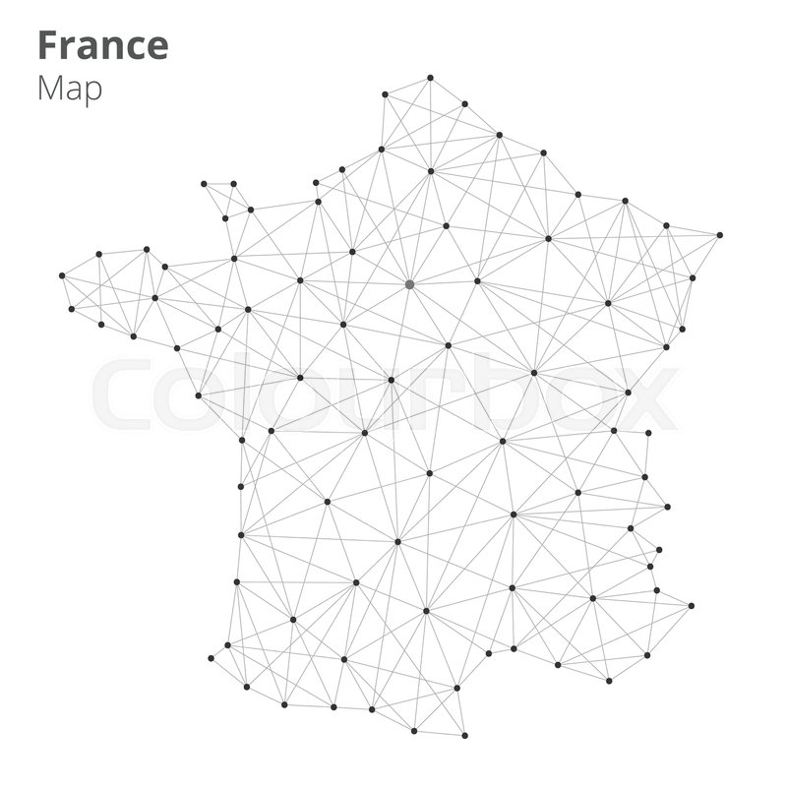



## LTR ICO PLan

### **Head words**

* An quick short introduction of what we are, what we do, how and when we do in Lottery market by using blockchain..

**LTR COIN PROJECT – HELPING TO BUY A GLOBAL LOTTERY**

1. **Introduction about Buy Lottery and LTR Token Service**
2. **Lottery market online**

* The annual growth rates are about 4,3%. In 2016, the total value of the global lottery market is about $260 billuon USD. Simultaneously, with the development of Internet and mobile phones, online lotteries have an tendency to grow everywhere
* However, there are a lot of challengens which face the lottery industry.That ensuring the fairness of the game is still the biggest challenge
  + *Is the ticket really a lottery?*
  + *Is amount of money accumulated in the ticket?*
  + *Is it really random and safe?*
  + *Is the real jackpot winner?*
  + *Are prizes returned in the right amount and time?*
* Users from other countries don’t easily participate in the largest lottery in the world such as Mepa in the United States because of many barries
* Some strict rules in other countries prevent users tfrom using online lottery services
* Some online sites allow players to buy lotteries around the world, but high service fees, difficult using, as well ass fraudulent risks and poor management. Blockchain technology can address the beliefs of lottery, and online lottery
  1. **The market of buying lottery**
* There are certain times that the Powerball Lottery Prize has peaked at $759 million. Not only American people but also many people around the world want to try their luck. According to the Power ball, palyers are not necessarily US citizens or long-term residents of the country, players are inside orr outside of the United States who may buy Powerball tickets from a licensed retailer or authorized ticketing authority if the age is aprropriate withe lottery rules (over 18 years old). So, citizens ot the world having needs to participate can fully buy Powerball tickets to win prizes. However, finding a licensed retailer or authorized Powerball lottery ticket sales are all through the internet site as <https://www.thelotter.com/>.
  1. **Advantages and disadvantages of current services**
* Services can assist customers to provide services by purchasing via Credit Card. There is no any legal guarantee to pay the bonus, although the website claims to pay fully for customer
* High transaction costs due to complicated process: buy tickets, scan and confirm, slow transaction speed.
* Simply used for buying services which do not meet other needs (buy, sell, trade…) or buy their own lottery tickets, or convert to other forms of entertainment

1. **LTR solution provided**

* LTR provides online lottery and online lottery ticket which is synthesized on blockchain technology:
* **Lottery purchase service** (via blockchain and smart contract is LTR token). Customer will use the app to access:
  + *Lottery options of countries like USA, Europe…and register lottery code*
  + *Based on information on lottery purchase requirements, the LTR smart contract generate a proof of the client with proof of work and power of stake, which forms blockchains and can’t modify, all members of the blockchain network define and prove history of your purchase of lottery tickets*
  + *Pay in LTR*
* **Lottery online** (and some lottery entertainment services) on blockchain technology provided by LTR
* **Payment services in coin is coded Itr for other bonus services such** as bonus football betting, predicting sports matches such as tennis, boxing…
  1. **Advantages of LTR Lottery technology:**
* Ensure the reliability of the transaction: Customers purchase lottery tickets via the LTR service, which is confirmed by the community through block technology, using authentication via PoS (power of stake) which is the highest security
* Smart contract mechanism is completely performed automatically
* Immediate trading: When customers buy lottery tickets, they will be rewarded immediately if the reward is based on the term of the smart contract on the blockchain
* Completely anonymous: Customers participate in the service will be completely anonymous, ensure privacy and information sercurity
  1. **How to use with LTR service users:**
* Use the application (web, mobile app) to access the service
* Charge money in your LTR account on the service (transfer from the LTR token trading platform)
* Selecting service and registration lottery code want to but, payment by LTR token
* Based on the information of pair number, the application creates smart contracts with terms:
  + *Customer service*
  + *Purchase code*
  + *Quantity of purchase*
  + *Total amount of money*
  + *Time (day,month, year, hour, minute, second, millisecond)*
  + *Smart contract terms*

This system will store the transaction as blockchain

* 1. **Lottery ticket purchase service**
* You order lottery tickets through LTR application and pay by LTR tokens
* Our company purchase directly at the lottery companies of the countries which have signed with authorized agency so as to meet your requirements and the evidence of this transaction is saved by email. You can search via smart contract ERC 20, as well as the account on the buylottery.ord website or through the app (android, ios), the evidence of this image, the code, the smart contract can not be modified by deleting, correcting. Therefore, when the customer has selected the number and ordered to pay in the Itr token, the contract is permanently saved on the block chain network and anyone has the right to see without editing. It is the highest information security of the blockchain technology platform
* In case that customers win, we will reward and convert to cash or transfer bank account directly to you. In addition, customers can receive LTR, BTC, ETH are code coin if you want. The prize money will automatically be paid to you according to the prize value when you purchase the ticket after deducting the tax amount of the host country. You do not have to pay any extra money
* If customers want to go the place of reward, we will provide lawyer services and detailed instructions about legal and administrative procedures to receive awards directly in the country
  1. **Online LTR ticket service**
* You order LTR ticket through LTR issuers, LTR applications and LTR tokens. Daily LTR will issue online tickets 4 times/day, using random dialing technology
* In the case that the customer win, the corresponding LTR Token will be automatically paid to you according to your smart contract when you purchase the ticket

1. **The roadmap of LTR service development**

* Stage 1 (2018):
  + Issue ICO – raising funds to launch LTC token project on ERC 20 platform - (July/2018 to December /2018)
  + Building a website to buy lottery tickets with LTR tokens (July/2018 to December/2018)
  + Negotiate and sign contracs with important lottery partners in Vietnam, Asia, Europe and the US (10/2018 onwards)
* Stage 2 (2019):
  + Use LTR to buy products and services of Ltr.com
  + Lottery ticket purchase service in countries and territories
* Stage 3 (2019 onwards): Use LTR as an intermediate currency coded as payment for other services on buylottery.ord as predicted football and sports which provided by buylottery

**Mode to sales revenue for LTR**

* Percent discount when customers buy lottery tickets or buy LTR online lottery
* Discount up to 10% on each purchase, for example, basis price $10, buying price $11
* Discount % on each transaction when withdrawing LTR tokens on trading floor
* But this discount is used to pay for staff and management fees, server infrastructure, banking costs, audits and operating costs

1. **How Token works and use LTR Services Online**

* Customers purchase and use LTR tokens so as to:
  + *Buy lottery tickets in the US, Europe and around the world*
  + *Purchase of buylottery.org services for gambling, betting, soccer betting, buylottery play an intermediary role in providing service platforms and LTR for customers to use*
* Forms of LTR, using the online lottery service:
  + Buy LTR coin when crowsale token and ICO
  + Buying and selling Itr transactions on the world
  + LTR reward when inviting others to participate
  + Play games and earn prizes in LTR
  + Paying bonus by inviting others to use the service

1. **Roadmap project**

* July, 2018: Announced the project and conducted ICO to create capital for the project, simultaneously programming application (web, mobile app) for the website buylottery.org to buy tickets in the world
* October.2018: Negotiate and sign contracts with the big lottery partners in VietNam, Asia, Europe, and USA

December, 2018: Run tests and test applications and service websites include: Buy tickets in Asian, European and American countries via web and application

* 1/2019: Purchasing ltr coin on international trading floors
* 3/2019: Official website buylottery.org launches and lottery ticket purchase applications start to operate.

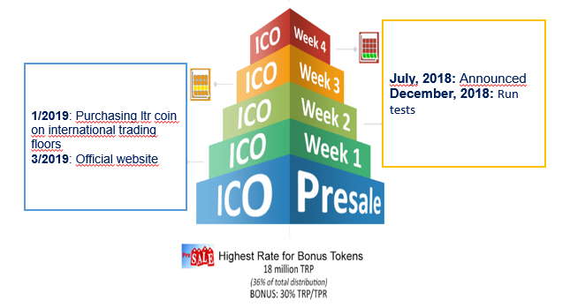

1. **Project ICO**
   1. **Number of token issued**

* LTR plans to issue 100 billion Itr of token with a value of 0,001 USD/1 token via ERC 2.0 platform, buy token in Ethereum or BTC
* Presale, with ICO investors, will be offered 0.0005$/token. At the start of the ICO, the discount rate will decrease from 40% per month (August/2018) to 30%, 20%, 10% , 5% until the end of December/2018
  1. **How to allocate token**
* ICO will open to sell 30.000.000.000 tokens. The remaining 70.000.000.000 will be frozen within 1 year and the expected token allocation is as follows: 10% for the team to develop the project and 20% by founding team and advisor, 70% will be issued to reward users with beneficial behaviors such as buying online lottery tickets online through buylottery.org and making bonuses on the web
* Of the 30 billion tokens sold, ICO is expected to allocate funds to the project as follows:
  + *20% bonus for affiliate marketing (referral purchase)*
  + *20% for the project team (founder, team, advisor)*
  + *10% for marketing and promotion*
  + *50% for project development (web buylottery.org buy lottery and android application, IOS online lottery ticket)*
  1. **The stages of ICO sale**

It is expected that the process of opening LTR sales is as follows:

* In July/2018: opening for sale to the original investors and founders
* In August/ 2018: sales through the ICO, referral program and affiliate marketing program token sales and free gifts when users advertise their friends to buy LTR
* In December/2018: end the ICO, pay bonus and converts tokens for customers corresponding to the purchased tokens and bonuses
  1. **Payments**
* Customers move BTC or ETH into Wallet LTR to convert to ltr token number respectively
  1. **Token releasing plan**
* At the end of the sales phase, customers will be transferred to the registered token (paid) within 4 weeks.

1. **Development team, consultants and partners**